Constantinople
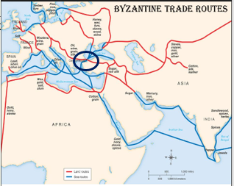
Directions: Read page 64 in History Alive and answer the following questions.
1. What about Constantinople’s location that made it an ideal capital of the Byzantine Empire?

2. In the chart below describe different aspects of what life was like in Constantinople.

Postcard from Constantinople!!
Suppose that you are a trader visiting Constantinople for the first time. On the left side of the postcard below, write a few sentences to a friend back home describing what you see as you walk through the city’s streets. On the right side, address your postcard to a friend in a faraway land selected from the map found on page 64 in History Alive. On the front of the postcard draw an illustration showing what life was like in Constantinople.

Rubric for Success
Criteria | Possible Points | Earned Points
Does your post card include at least three well-explained facts?  Are the facts relevant to Constantinople? | 6 (2 per fact)
Structure of the Postcard:  Is your postcard written like it is to a friend? (Letter form)  Or  Did you just list facts? (What not to do for this) | 1
Creativity:  Does your postcard picture illustrate a key aspect/or several, of what life was like in Constantinople? | 1
Total points | 8

