Early Arabia
Examine the map below and answer the questions that follow.
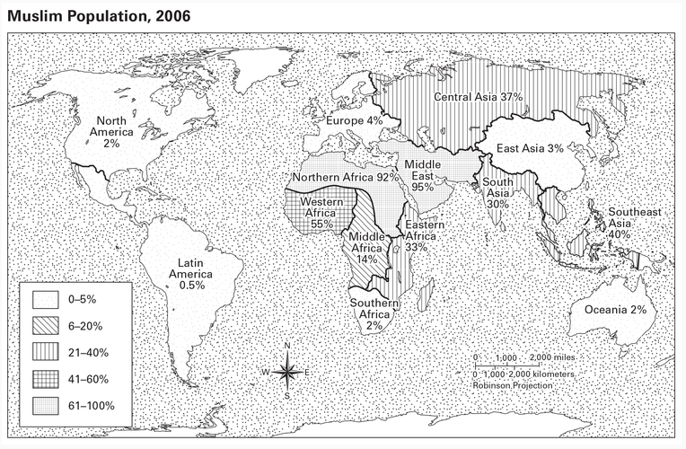
1. What regions of the world have the highest concentrations of Muslims? The least?

2. Based on this map, in what region of the world do you think the Islamic faith originated? Why?

Read the introduction.
1. Who is Muhammad?

2. Why is Mecca (Makkah) an important city in the Middle East?

Early Arabian Culture Exit Ticket
Read the section “Arabia in the 6th Century” and answer the questions that follow.
1. Describe Mecca around the time of Muhammad’s birth. Use the following terms in your description: desert, prosperous, trading city, merchants, religious center.

2. Why was the Ka’bah built, and how was it used at the time of Muhammad’s birth?

3. Explain the ties that most Arabs shared during this time. Use the following terms in your explanation: government, nomadic, tribes, culture, language.

Early Cultures of Arabia

