The Eastern Orthodox Church
1. Describe the relationship between religion and government in the Byzantine Empire?

2. What role did state religion play in the lives of the people in the Byzantine Empire?

Orthodox Church and Catholic Church Comparison
Directions: For each aspect of Christianity identify how the Catholic and Orthodox Churches are similar and different.
Catholic Church | Similarities | Eastern Orthodox Church
Church Hierarchy (Who was in charge?)
Liturgy (What happens during a church service)

Architecture and Art:
1) What was the important architectural style used on the Hagia Sophia and other Orthodox Churches?

2) What are icons and why did Christians use them?

Beliefs and Practices of the Eastern Orthodox Church Exit Ticket
Below are images that describe different aspects of the Eastern Orthodox Church that we learned in class. Next to each image write at least two captions/descriptions from information learned in class that relate to each image.
1)

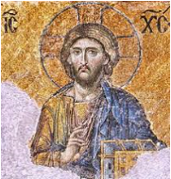

This is a Byzantine icon of Jesus.
He is holding the Bible.

2)

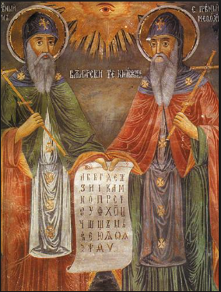
In this alter icon, saints Cyril and Methodius hold a document with Greek letters.

3)

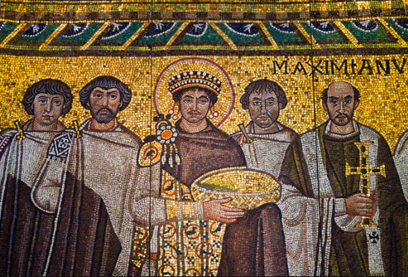
This is a mosaic of Emperor Justinian found in a church in Italy.

4)

