Empress Theodora

In this unit so far, you have learned about the fall of Rome in 476 and how the eastern half of the Roman Empire continued as the Byzantine Empire. You also met Byzantine emperor Justinian I and his wife, Theodora. Empress Theodora lived a very unusual life. Although she was born a peasant, at a time when that typically meant a hard and unremarkable life, she made many contributions to women, the Byzantine Empire, and the world.
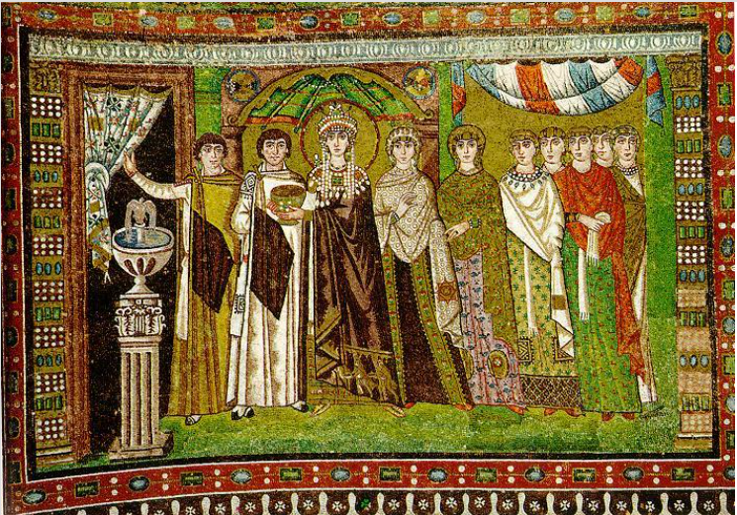
Theodora was born around 497 C.E. Her father was thought to be a bear trainer at the hippodrome in Constantinople. Remember, the hippodrome was where chariot races and other entertainments were held. After her father's death, Theodora began working as an actress and a dancer at the hippodrome. At that time, being an actress was not a noble (respected) profession, but there were few ways for women to make a living. Eventually, she left the theater and took a job spinning wool. She lived and worked in a house near the palace.

It was there that she met Justinian, the emperor's nephew. He was much older than she was, but the two fell in love. Justinian wanted to marry her, but, by law, he could not. Under Byzantine law, peasants could not marry members of the upper classes. But Justinian was not to be stopped. He used his position as a member of the royal family to get the law changed. In 525, Justinian and Theodora were married. And, in 527, they were crowned emperor and empress.

Although they did not officially rule as joint monarchs, Theodora had great power and influence. She used her influence to create many new laws to protect women and their rights. These laws granted women more rights in divorce and allowed women to inherit and keep property. They also made the abuse of women and children illegal.

Empress Theodora is also recognized for saving Justinian's reign. In 532, a riot broke out at the hippodrome between two rival political groups: the Blues and the Greens. The riot soon turned into a revolt. Many public buildings were destroyed. Unable to control the mob, Justinian and his advisors got ready to flee. Then, at a meeting of the government council, Theodora spoke out. She told Justinian that death was better than exile and disgrace. Her speech convinced them all. Justinian's generals attacked the rebels and eventually restored order.

Following the revolt, Theodora and Justinian had to rebuild Constantinople. They transformed it into one of the most beautiful cities in the world. They built aqueducts, bridges, and more than 25 churches. The greatest of these is the Hagia Sophia, which translates from Latin as "Saint Sophia" and from Greek as "Holy Wisdom." It is considered one of the architectural wonders of the world.

Theodora died of cancer on June 28, 548. Her body was buried in one of the churches the emperor and empress had had built in Constantinople. Although Justinian ruled for 20 more years, it is said that he never recovered from her death and went every day to light candles at her grave.

