Islamic Religious Practices
Next to each image explain how it relates to the religious practices of Muslims using information learned in class. Connect each image to at least one of the Five Pillars of Islam (fasting, daily prayer, declaration of faith, pilgrimage, charity) and the Qur’an, Shari’ah Law, and Jihad.
1.
______________________________________________________________________________________________________________________________________________________________________________________________________________________________________________________________________________________________________________________________
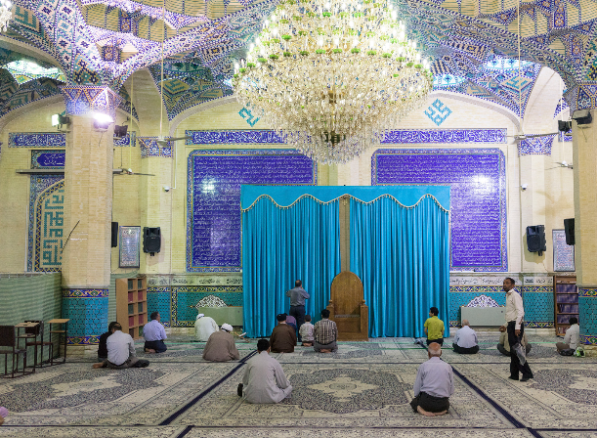

2.
____________________________________________________________________________________________________________________________________________________________________________________________________________________________________________________________________________________________________________________________________
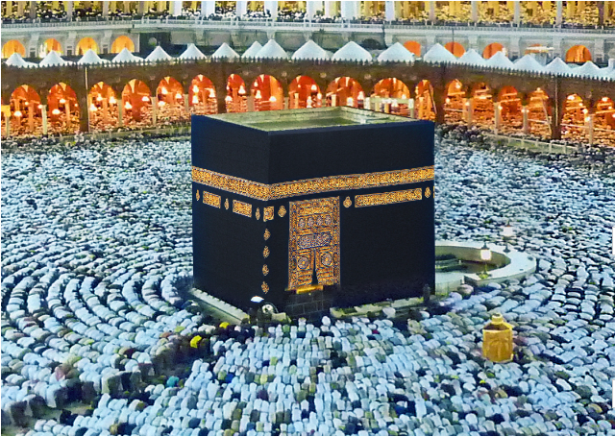

3.
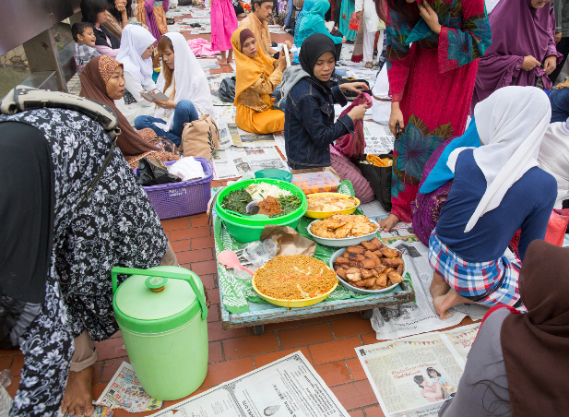
______________________________________________________________________________________________________________________________________________________________________________________________________________________________________________________________________________________________________________________________

4.
__________________________________________________________________________________________________________________________________________________________________________________________________________________________________________________________________________________________________________________________________________
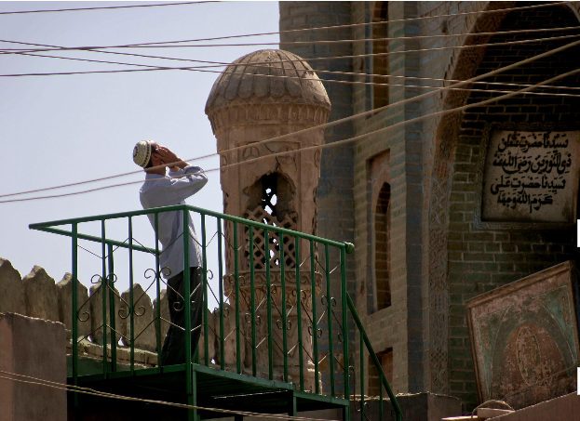

5.
____________________________________________________________________________________________________________________________________________________________________________________________________________________________________________________________________________________________________________________________________
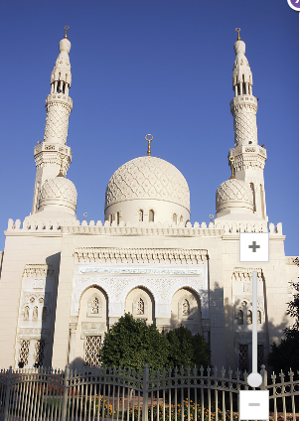

____________________________________________________________________________________________________________________________________________________________________________________________________________________________________________________________________________________________________________
6.
