Personal Coat of Arms Project
In the Middle Ages, helmets and other armor began making it difficult to tell armed warriors apart. The solution was for each knight to paint something personal on their shield. These designs were important in battle, but also functioned as team uniforms when knights met in tournaments. The symbols used on these coats of arms were chosen carefully to represent and individual or an entire family. The study of the symbols, colors, and patterns used coats of arms is known as heraldry.
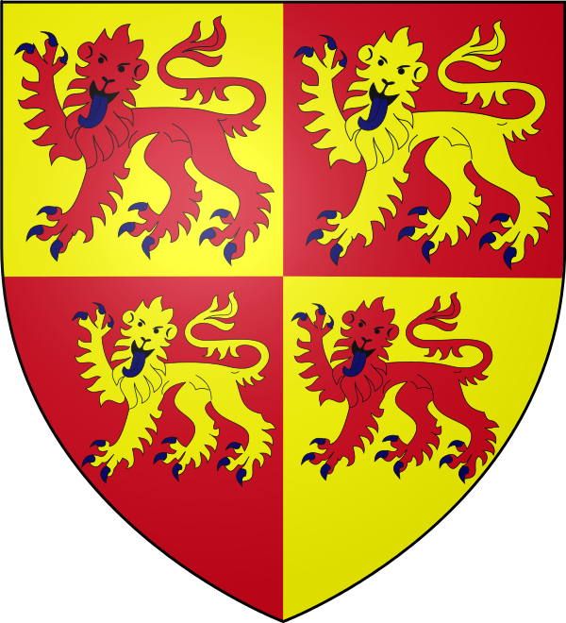

DESIGN YOUR OWN COAT OF ARMS
Create your own coat of arms based on your hobbies, personality, character, and family. Read through the materials available in class and study the different options—which best represents you? Can you think of any other animals or symbols that you could use on your coat of arms?

Include the following information on your own coat of arms:
- Birth Order- Are you the first, second, third, etc. child in your family?
- Color- What traits would you like to show through the use of color on your coat of arms?
- Charges- What types of charges would you like to appear on your coat of arms? The charge represents a trait or characteristic of the person whom the coat of arms belongs to (Minimum of three charges)
- Motto- Words or a phrase that represent you. This can go at the top or the bottom of your shield.
Your Coat of Arms will be created in class. You will need to be creative and follow directions to ensure that your project earns the best grade possible.
1. Look over the heraldy materials and complete the brainstorming worksheet
2. Create your Coat of Arms and turn in with your rubric.
3. Compose a paragraph explaining the key points of your personal Coat of Arms. In addition, explain why these traits would be key in your success as a knight. This paragraph will be done on loose-leaf paper, or it can be typed.

The project is due: _______________________________________
Coat of Arms Rubric
Required Elements  - Birth Order  - Color  - Charge (3)  - Motto | 6 points
Graphic Placement-  Are your graphics placed appropriately? | 4 points
Neatness/Effort  Does the coat of arms is neat and reflects excellent effort on the part of the author? | 4 points
Paragraph  Does the paragraph explain why the chosen designs represent the author? (Charges, Shield Color, Motto)  Does the author explain why these characteristics would help them become a successful knight? (Connect to what we learned about knights in class) | 6 points

Total points: ________________/20

