The Great Schism of 1054: Conflict Between East and West
Contrasts with the West
Medieval Europe and the Byzantine Empire were united in a single faith, Christianity. Over the centuries, however, cultural, political, and religious differences brought the two parts of the old Roman Empire into conflict. The two regions had been quite different even in the days of the early Roman emperors. The eastern half of the empire had many cities, much trade, and great wealth. The western half was mostly rural and agricultural, and not nearly as wealthy.
Other differences became more pronounced after the fall of Rome. Byzantine culture was shaped mostly by its Greek heritage. The west was influenced by Frankish and Germanic cultures, the people who invaded the Roman Empire. In the city of Constantinople, the people spoke Greek. In the west, Latin was the language of the scholars, diplomats, and the Church, but was not spoken by the commoners.
Perhaps most important was the conflict that developed between the churches of east and west. After the fall of Rome, popes gradually emerged as powerful figures in western Europe. The popes claimed supreme religious authority over all Christians. The emperors and patriarchs (Orthodox bishops) did not claim power over all of Christianity.
Iconoclasm
The first major disagreement concerned religious icons. Religious icons were widely used throughout Christendom. Icons are pictures or representations of a sacred person or persons. They were meant to put the viewer of the image into a spiritual frame of mind. Christians east and west would use icons of Jesus, Mary, and saints in worship and prayer by praying or lighting candles before them. However, some Byzantines thought this devotion to icons went too far. They feared that people worshipped the icons themselves as gods.
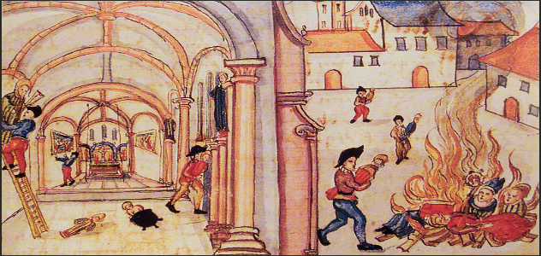
In 726, Byzantine emperor Leo III, fearing that the icons were being worshipped as gods, banned the use of icons in all Christian churches and homes, and ordered their destruction. This policy of iconoclasm (“icon smashing”) led to the destruction of much religious art. Throughout Christian lands people cried out in protest, and many Byzantines refused to comply with the policy. Pope Gregory III, who was in favor of icons, condemned the emperor’s actions. Gregory thought that icons were important for honoring holy people of the past and providing a way for those who could not read to learn about their faith. The pope also protested because the emperor’s actions applied to areas of Italy which were under Byzantine control. This meant that Roman Catholics would have to obey, something the Pope would not see happen.
The Byzantine Empire eventually lifted its ban on icons in 843, and have been an integral part of their worship ever since. But, the dispute over icons cause a major split between the eastern and western Christian churches. It also helped drive popes in Rome to look for support and protection against their enemies.
The Crowning of a Holy Roman Emperor
Another major disagreement occurred in 800 CE. At the time, Empress Irene was the ruler of the Byzantine Empire. Through plots and conspiracies, she arrested her co-ruler, her own son, and had him blinded, ensuring that she would have sole rule of the empire. Because she was a woman though, Pope Leo III did not view her as true or strong enough to govern. He wanted the protection of a strong leader to help defend the Church in the west from any war with the Byzantines. To do this he solidified an alliance with the king of the Franks, Charlemagne, by crowning him the only true and holy Roman Emperor. Thus, Charlemagne became the first Holy Roman Emperor. The pope’s actions outraged the Byzantines because they believed that the Byzantine emperor was the only true and rightful Roman emperor.

A Schism in the Church: The Final Break
Matters over who was supreme in the Church, the pope in the west, or emperor and their appointed patriarchs in the east came to a head in 1054. The patriarch of Constantinople, Cerularius, wanted to reassert Byzantine control over churches in southern Italy. He closed any church that celebrated mass (church service) in the western style. Pope Leo IX was furious. He sent a cardinal to Constantinople and marching up to the altar of Hagia Sophia he laid down a Papal bull (a proclamation from the pope) excommunicating Cerularius. Excommunication was a serious matter because it excluded someone from participating in services or receiving the sacraments (holy communion), it meant that you would spend eternity in hell, and you were essentially separated from society because you could not go to church like everyone else.
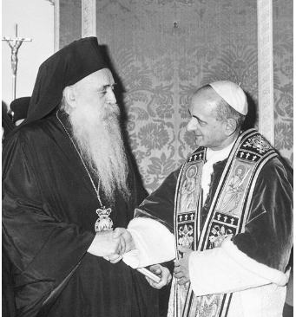
Cerularius responded by excommunicating the cardinal, thus finalizing the split or schism between the eastern and western Christian churches. Despite future attempts to heal the division, the Eastern Orthodox Church and the Roman Catholic Church were now separate churches. It would take 910 years before the mutual excommunications were undone in an agreement between Patriarch Athenagoras and Pope Paul VI in 1964.

