The Vikings- Source Analysis
Source A: The Anglo-Saxon Chronicles
1. What sort of document is this, and what do you think was its purpose?

2. Describe the activities of the Vikings in the passage (they are called pagans, heathens, pirates, and Danes). What do they do? Is any reason given to explain their activities?

3. Do you think this author is a reliable source? Why or why not? (Hint: Read the Introduction)

4. What view does this author have of the Vikings? Why?
5. Might his view be biased? Why or why not?

Source C- Letters from Alcuin
1. What type of source is this? What is its purpose?
2. How does it describe the Vikings?
3. Does the author provide any reasons to explain why the Vikings act why they do?
4. Do you think this author is a reliable source? Why or why not?
5. Might his view be biased? Why or why not?

Source B- The Annals (Historical Recordings) of the Abbey of Xandan
1. What sort of document is this, and what do you think was its purpose?

2. Describe the activities of the Vikings (called “heathens” or “Northmen). What do they do? Is any reason given to explain their activities?

3. The author lived at an abbey or monastery. How might he view non-Christians?

4. What view does he seem to hold of the Vikings? Why?

5. Might his view be biased? Why or why not?

6. How does this source describe what is happening in other areas of Europe?

Reflection
1. Taken together, what do these sources tell us about the Vikings?

2. The Vikings did not have writing. How might this influence our understanding of their culture?

The Vikings: Map Examination
Examine the map “Viking Raids and Settlements” in your Historical Atlas page 67.
1. Using “Viking Raids and Settlements” map, label the blank map below.
Include: a) routes that Vikings travelled b) areas Vikings raided c) areas Vikings settled
England, Ireland, Denmark, Norway, Sweden, Holy Roman Empire, France, Cordoba, Kievan Rus (Russia), Byzantine Empire
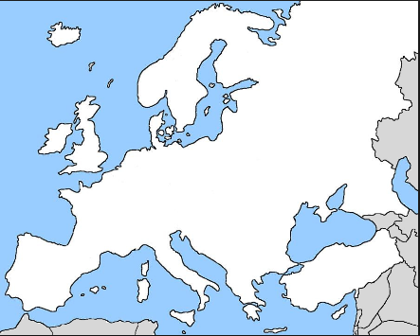
2. Where do the Vikings come from? What modern day countries make up this region?

3. Looking at where they come from, why would the Vikings be good sailors/seafarers?

4. Prediction: Why might the Vikings feel the need to travel to other places?

5. What areas did the Vikings settle?

6. Hypothesize: Why would Vikings target monasteries and churches in many of their raids?

