The Vikings
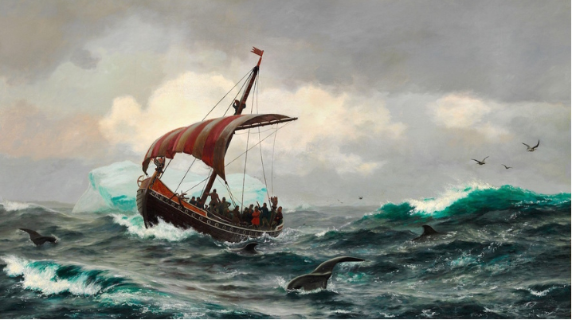
Perhaps the best-known event of the early Middle Ages was the dramatic entry of Scandinavian peoples into the kingdoms of Europe. From about A.D. 800 to the 1000s, a vast number of Scandinavians left their homelands to pursue their fortunes farther south. The Vikings, in sleek, fast-moving ships landed on the shores of France, England, Spain, the Mediterranean Sea, down the rivers of Western and Eastern Europe, and even to the walls of Constantinople. Over the next three centuries these traders, pirates, and settlers had a lasting impact on the culture of the Middle Ages. These fearsome raiders became known collectively as Norsemen, or “Northmen,” though they are better remembered as the Vikings.
Contrary to some popular perceptions, the Vikings were not united by common ancestry, nationality, or other sense of “Viking-ness”. Most came from parts of Scandinavia now known as Denmark, Norway, and Sweden, but there are records of Vikings from Finland and other regions. To the European people they raided, the Vikings shared certain features: They were great sailors and ferocious fighters, and they came from foreign lands. They were not viewed as “civilized” by those they traded with or raided; and most importantly, they were not Christian.
What caused these attacks to occur?
Many Europeans at the time believed the Vikings were sent from God to punish Christians for their sins. Though there is no definite answer but scholars have developed a well-accepted theory. They explain that the Vikings were searching for resources, land, and trade contacts. The region known as Scandinavia is a cold, mountainous place, with shorter summers than the rest of Europe. These geographic factors meant that farming was severely restricted in the Viking’s homeland.
Vikings were broken up into small kingdoms who would fight each other often. Population increases and a lack of good farmland led to conflict between groups and put pressure on many Scandinavians to search for new homes. Another pressure was the lack of opportunities for lesser lords and commoners, who could find new sources of revenues (income) and prestige in raiding and trading. The Vikings unintentionally chose an ideal time to raid because with Charlemagne dead and his descendants fighting over power, Europe was disorganized and fragmented.
Raids
Many historians mark the beginning of the Viking Age with an attack on the Lindisfarne monastery off the northeastern coast of England in 793. The attackers plundered the place, killing or enslaving the monks who lived there. This and later attacks would rock Europe and the Christian Church to its core. Viking religion and culture emphasized bravery and prowess (skill) in battle as a sign of status, manhood, and pride. Vikings had many different types of jobs, but saw their role of warrior as essential to their own status in this world and in the afterlife.
It is important to remember that the Vikings were not Christian, thus they felt in no way restrained from attacking religious sites and killing or abusing priests and monks. Churches and monasteries looked like easy targets because they were usually near bodies of water, were left undefended, and were most importantly sources of immense wealth. Over the next 300 years’ churches and monasteries would be ideal targets for Vikings who would haul away vast amounts of wealth to Scandinavia.
Vikings would stage hit-and-run raids against coastal targets. Appearing and disappearing before local rulers could react to the attack. After 830 though, the Vikings took advantage of conflicts in Europe to extend their activities farther inland. The key to the Vikings wide range success was in their transportation. The Viking long ship represented a significant innovation in sea travel. Built with overlapping boards, the Viking long ship was incredibly stable in open ocean waters but had a shallow enough hull to sail up river valleys. And so, the Vikings had vessels capable of long ocean voyages, but could attack settlements that lay hundreds of miles inland.
Since most Medieval settlements of any importance were located along coasts or rivers meant that the Vikings could strike at nearly all the population centers of Northwestern Europe. The ability of the Vikings to strike anywhere, their aggressiveness, their ability to appear out of nowhere and concentrate force in a particular place confused and terrified European rulers throughout Europe. The Vikings would learn that rulers would pay them huge sums of treasure in exchange for just leaving.
Viking Settlements
With a lack of farmland in their homelands, Vikings were always looking for areas where they could put down the sword and use farming tools. By the mid-800s, Ireland, Scotland and England had also become sites for Viking settlements as well as raids. These Viking settlers founded Ireland’s first trading towns, including Dublin and Limerick. They used bases on the Irish coast to launch attacks within Ireland and against English targets.
After 851, England endured waves of Viking invaders, mostly from Denmark. These Danish Vikings colonized England's north in an area known as “Danelaw.” There, they established thriving settlements of farmers and traders. In the first half of the 10th century, however, English armies began reconquering areas they had lost.
Viking forces had remained active on the European continent throughout the 800s. In 842, they sacked the French coastal city of Nantes, and attacked inland towns and cities, including Paris. They later struck major cities in Spain and Italy. In 911, the West Frankish king signed a treaty with Rollo, a Viking chieftain. The agreement ceded territory to Viking rule in exchange for the latter’s defense of the River Seine. This region of what is now northern France is still known as Normandy, or “land of the Northmen.”
In the 800s, Scandinavians — mainly Norwegians — had also begun looking westward across the sea. They colonized Iceland, an island in the North Atlantic. By the late 900s, some Viking explorers sailed even farther west and settled on Greenland. Eventually, Greenland-based Vikings, supposedly led by the legendary Leif Eriksson, became the first Europeans to reach North America, though they did not establish permanent settlements there.
In Eastern Europe, Swedish Vikings took advantage of vast river systems to travel and trade over large distances. Some founded settlements which would become major trade centers and even became rulers of unified Russian kingdom called Kievan Rus. Others had contact with Byzantine emperors, who would employ them as their personal bodyguards and elite troops in their armies.
Assimilation
The English reclaimed their lands from Danish rule in the 11th century, when Edward the Confessor, son of a previous English king, returned from exile and regained the English throne from the Danes. Upon Edward’s death in 1066, Harold Godwinesson, the son of a powerful English noble, claimed the throne. His army defeated a Viking invasion near York, but Godwinesson’s forces fell to William, Duke of Normandy, just weeks later. Crowned king of England on Christmas Day in 1066, "William the Conqueror" managed to defend his rule against further Danish challenges. Ironically, William was descended from Vikings who settled in France.
The events of 1066 in England effectively marked the end of the Viking age. By that time, rulers built fortifications which stopped many attacks, all the Scandinavian kingdoms had converted to Christianity, and what remained of the Viking way of life was largely absorbed into the culture of wherever they settled. Today, the Viking legacy lives on in the Scandinavian origins of some vocabulary and place-names in the areas they once conquered, in some of their law codes, and in legends about their gods, and fearsome warriors and their conquests. The impacts of the Viking raids and settlements disrupted the cultures of the Middle Ages. Kings were unable to effectively defend their realms and as a result gave more and more power to lesser lords who could defend their smaller regions. This form of government is called feudalism and would characterize European governments until the 1400s.

